**Upgradation Of SRS Client**

1. Uninstall existing SRS client from agent system

2. Install 8.5.366.04 Genesys SR Service On Agent Desk Using Administrator Rights

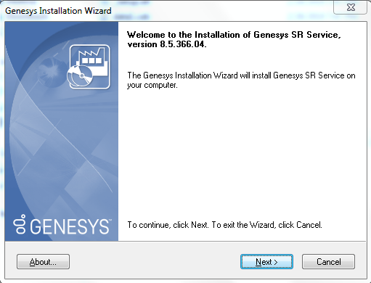

Select customized

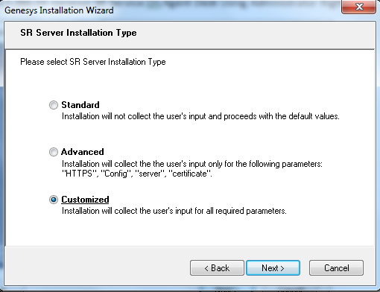

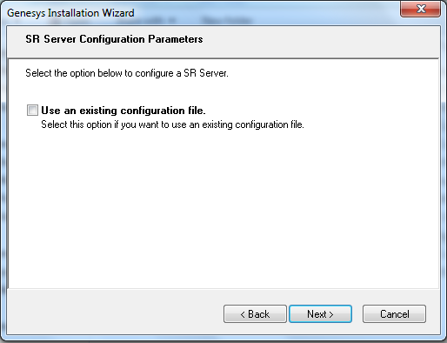

Untick **“Use HTTPS self-signed certificates”**

Change base url to [http://*](http://*)

Change GWS Server URL to <http://10.64.18.55>

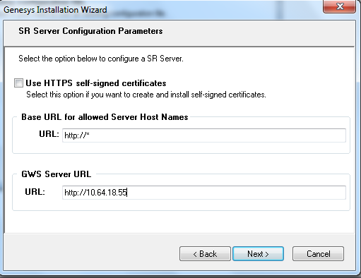

Select **“Do not validate the certificate”**

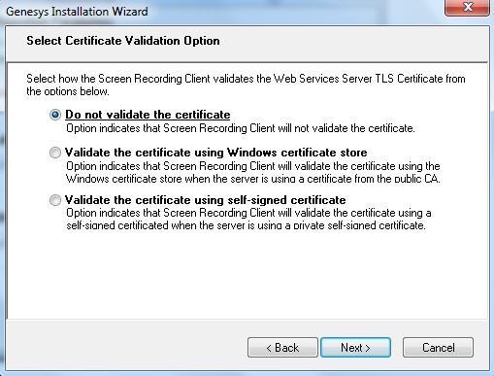

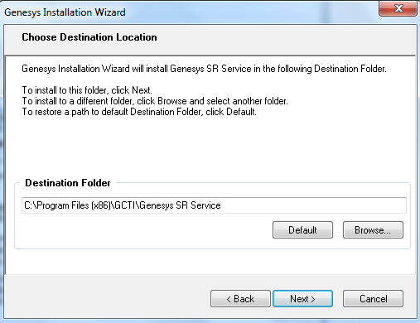

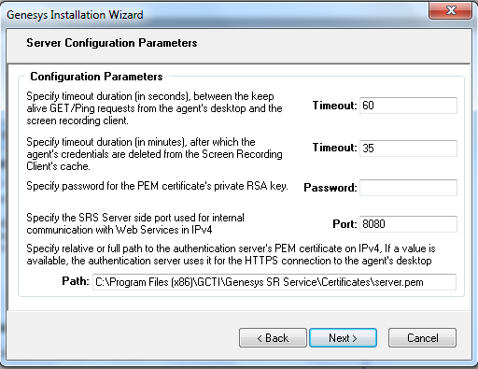

Untick **“Support IPv6”**

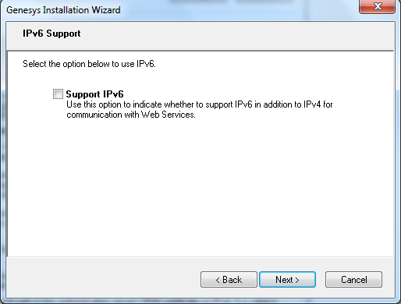

Select **“FQDN”**

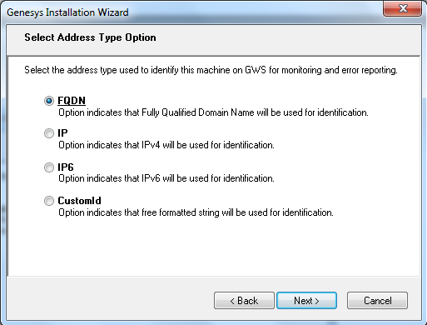

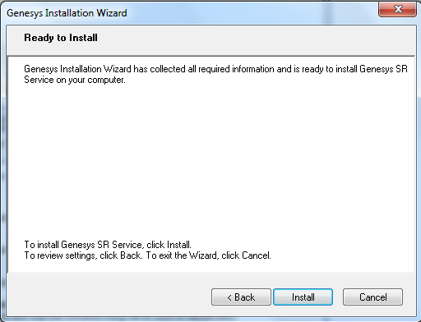

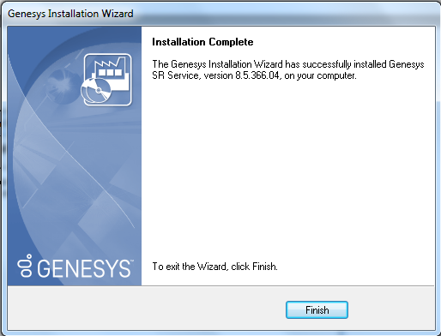

Replace “config.json” from provided

Make sure file name is **config.json**

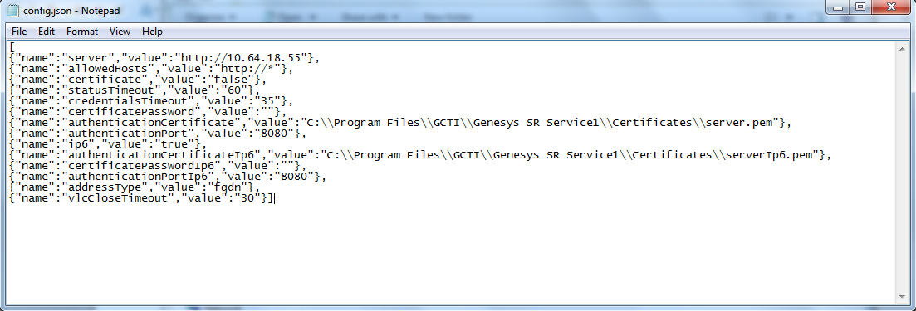

Use browser to get following output

<http://localhost:8080/version>

